**Airport Ticket Booking Management**



**Submitted By Submitted To**

**Name:** Rumman Ahmed Prodhan Nadeem Ahmed

**ID:** 18101018 Assistant Professor

**Name:** Sumya Akter CSE, UAP

**ID:** 18101029

**Appendix**

|  |  |  |
| --- | --- | --- |
| **No.** | **Topic Name** | **Page No.** |
| **1** | **Information of the Database** | **3-4** |
| **2** | **ER Diagram of the Database** | **5** |
| **3** | **Schema Diagram of the Database** | **6** |
| **4** | **Insert data into tables** | **7-9** |
| **5** | **Running Query** | **10-16** |

**Airport Ticket Booking**

This is a database for booking tickets of plane. Passengers can book their flights using this database. Authorities can update any Flight schedule. New planes or new pilots can be added or removed from the database. Passengers can also check their flight time and other important flight information.

**The information which are going to be available in the database**

**are given below:**

**Table:** Pilot

**Attributes:** pilot_name, age, gender

**Relations:**

1. Pilot – pilot_name – Plane

**Table:** Plane

**Attributes:** plane_name, capacity, pilot_name

**Relations:**

1. Plane – pilot_name – Pilot
2. Plane – plane_name – Flight

**Table:** Flight

**Attributes:** flight_fare, flight_from, flight_where, departure_time, arrive_time, flight_name, flight_date, plane_name

**Relations:**

1. Flight – Booking – Ticket Booking
2. Flight – passport – Passenger

**Table:** Passenger

**Attributes:** passenger_name, passport, age, gender

**Relations:**

1. Passenger – passport – Ticket Booking
2. Flight – passport – Passenger

**Table:** Ticket Booking

**Attributes:** passport, flight_fare, flight_from, flight_where, departure_time, arrive_time, flight_name, flight_date, plane_name

**Relations:**

1. Ticket Booking– Booking – Flight
2. Ticket Booking – passport– Passenger

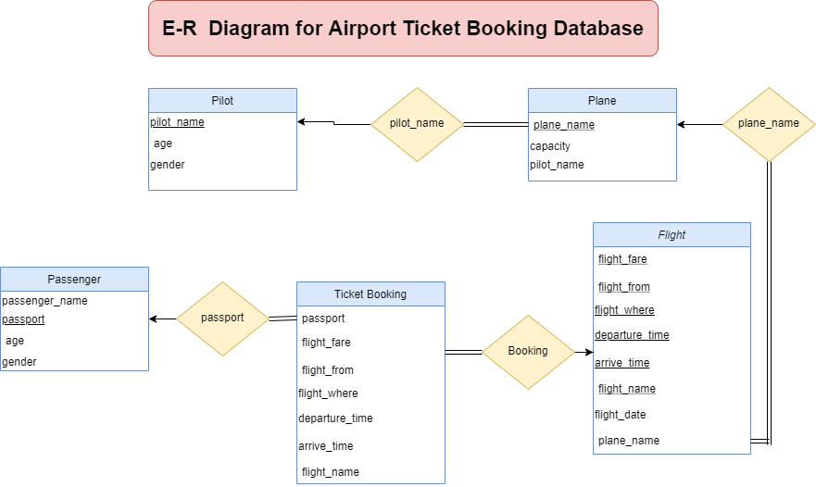 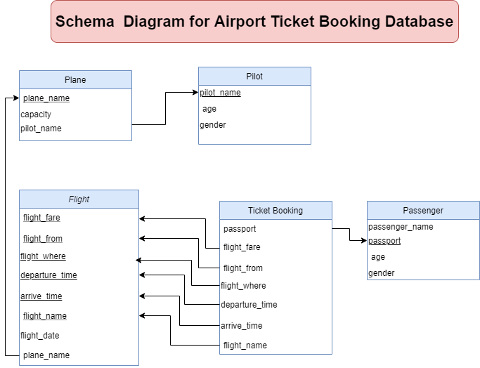

**Insert data into tables:**

**Table: Pilot**

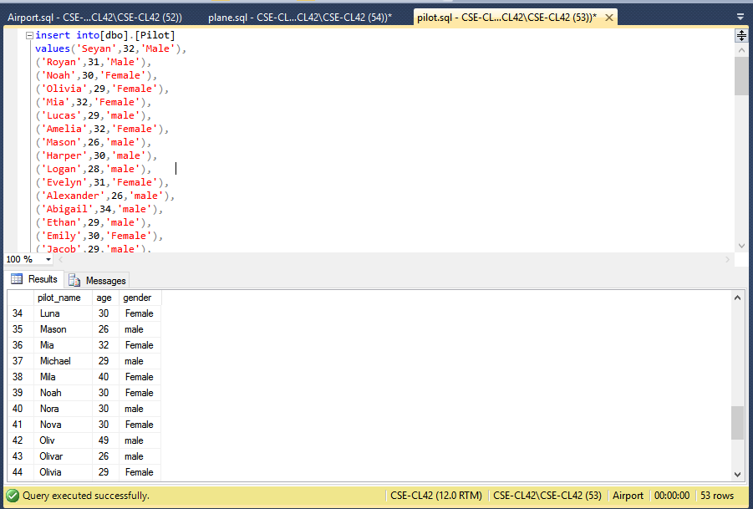

**Table: Plane**

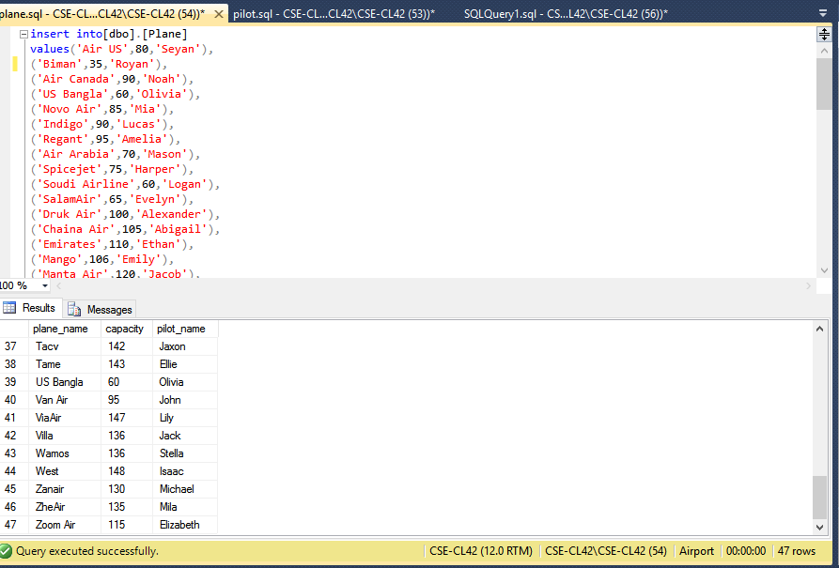

**Table: Passenger**

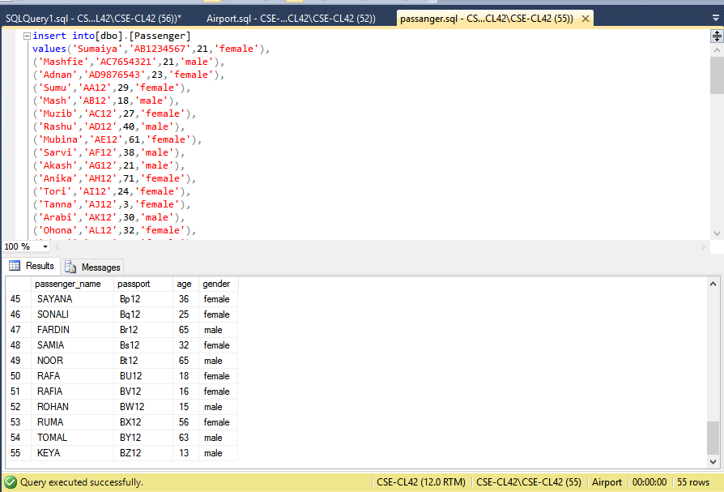

**Table: Flight**

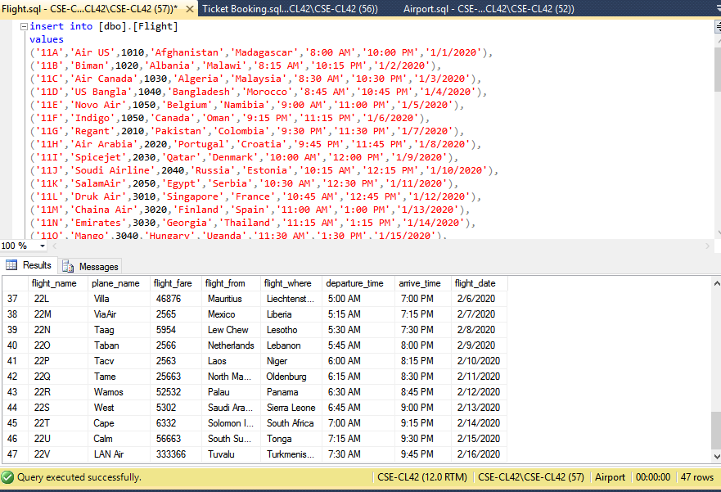

**Table: Ticket Booking**

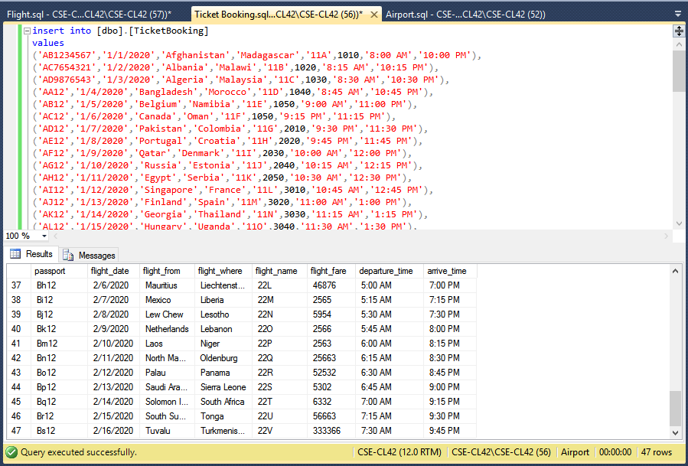

**Running Query:**

1. **Find the names of all passengers**

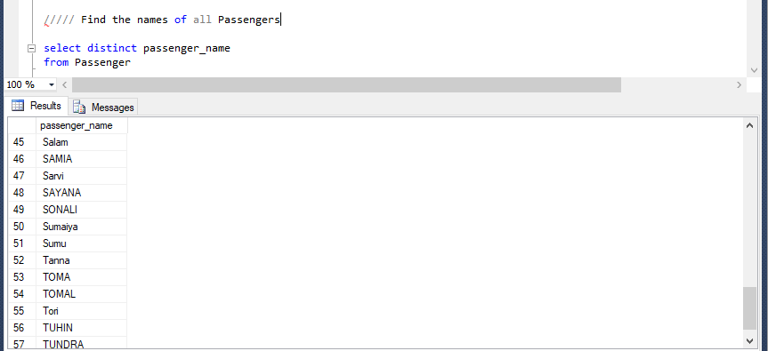

1. **An asterisk in the select clause denotes to “all attributes”**

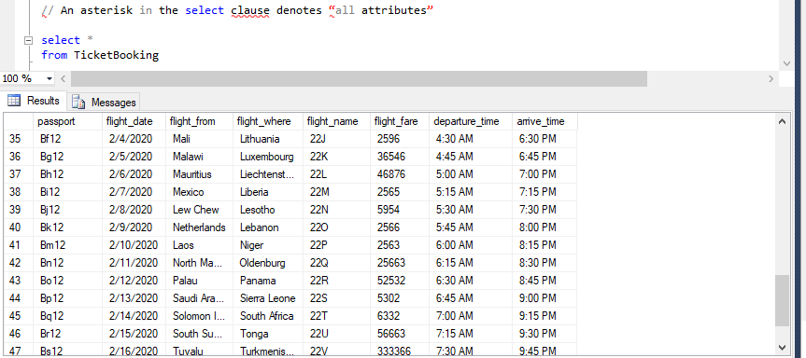

1. **To find all Flight Date from “Bangladesh” to “Morocco”**

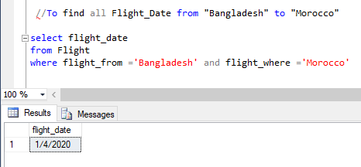

1. **Find the names of all Pilot who is under 30 years old**

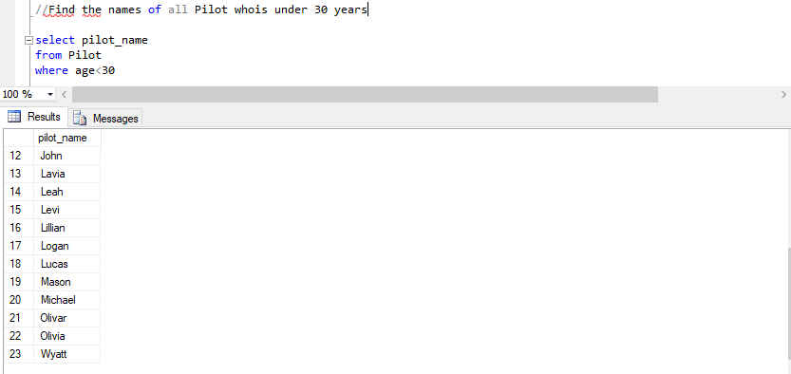

1. **Find the names of all passengers whose name includes the substring “Ma”**

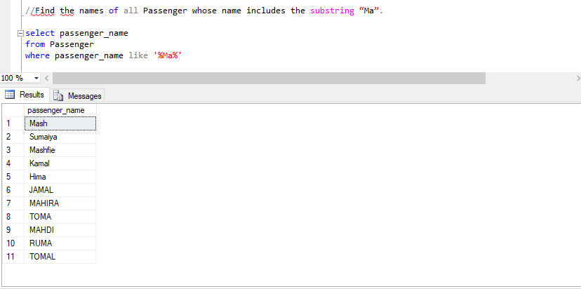

1. **List of the names of all plane in alphabetic ascending order**

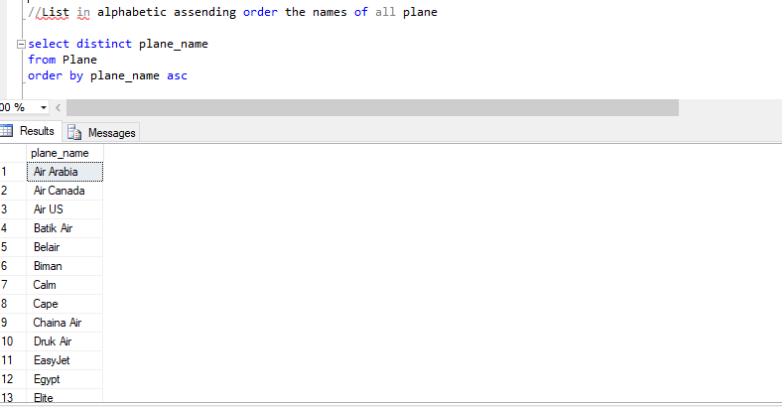

1. **Find the names of all plane with fare between $5000 and $7000**

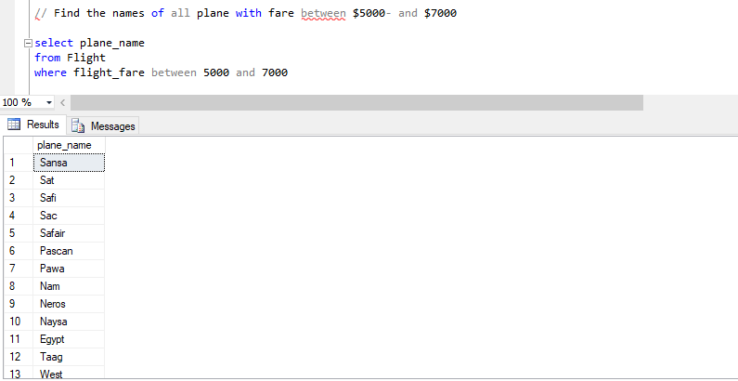

1. **Find the flight name of all flight that are less than the most expensive fare**

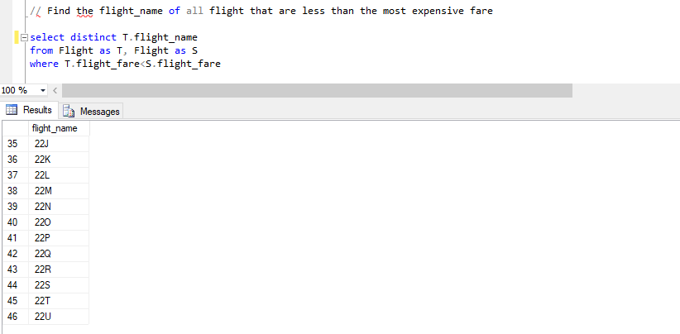

1. **Find all the fare of all flight**

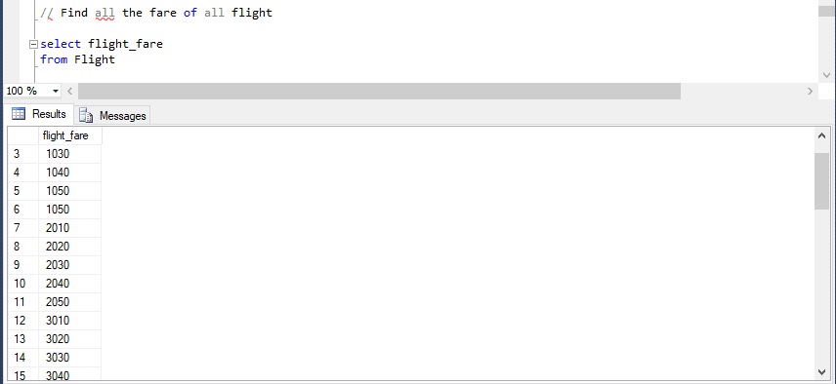

1. **Find the most expensive flight fare**

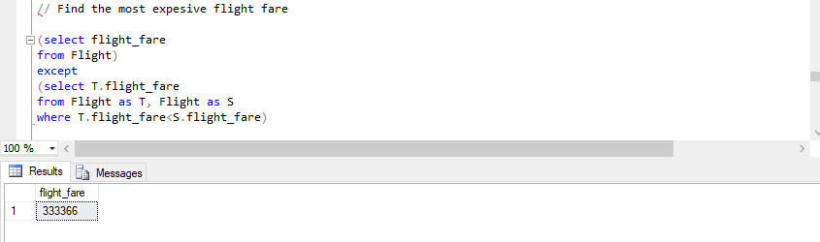

1. **Find the average fare of all flight**

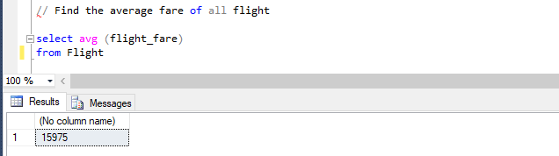

1. **Find the number of tuples in the ticket booking relation**

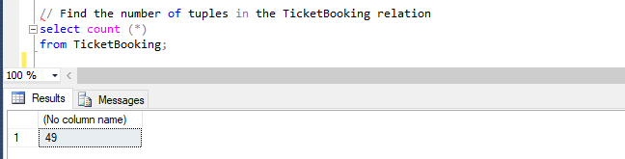

1. **Find average age of pilots**

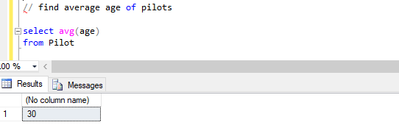

1. **Book a new ticket for Morshed (Insertion)**

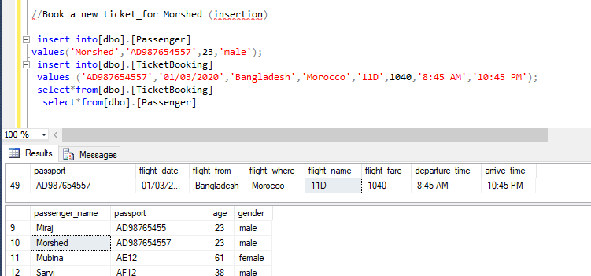

1. **Update a flight date (Update)**

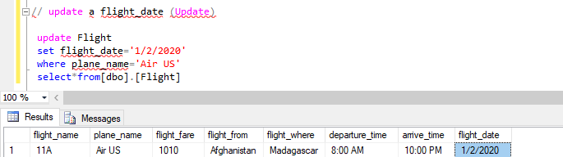

1. **Flight destination of “US Bangla” Plane**

